Order Of Service

Singing: Psalm 119c—CW page 111

Reading: Psalm 106:40-48

Opening Hymn: TLH 457

Reading: Hebrews 5:1-14

Request Hymn: CW Supplement 702

Reading: Luke 7:24-35

Sermon Hymn: TLH 605

Sermon Text: Acts 8:1-8

Saul Made Havoc

Prayer

The Apostles’ Creed, TLH page 12

Holy Communion

The Lord's Prayer

The Blessing

Closing Hymn: TLH 52
************

Bible Study: Lambs: Hamsters
Sheep: Deut. 13:12-18
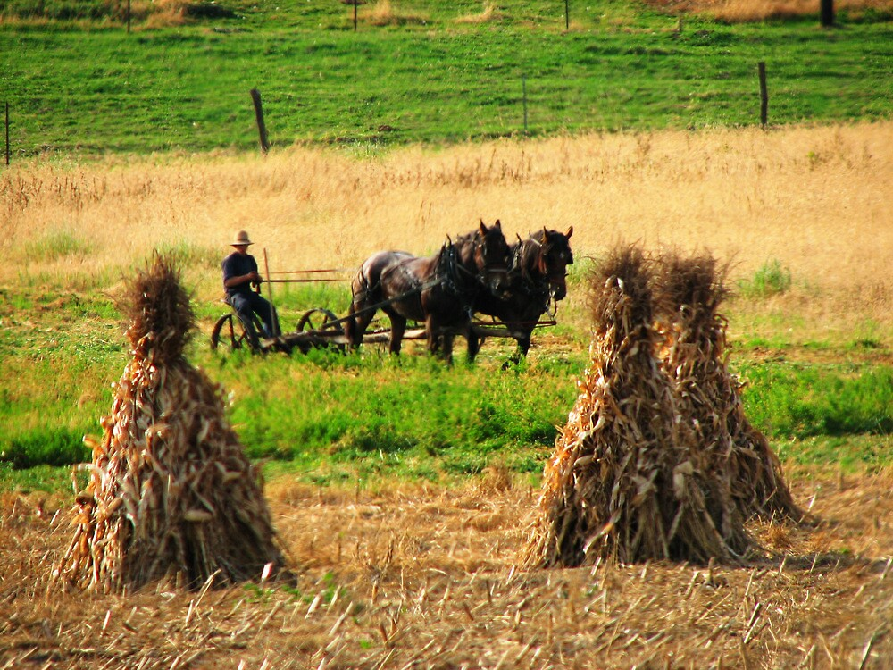

Harvest In Amish Country

Water
Of
Life

15 September 2024

W A T E R O F L I F E

Independent Christian Church—Conservative Lutheran Doctrine

Worship Service: 9:30 a.m.

Larry Cooper, Pastor E-Mail address:
lcooper@wateroflife.cc
Web Site:
www.wateroflife.cc

* * * * * * * * * * * * * * * * * * * * * * * * * * *

Sermon Text: Acts 8:1-8

Saul Made Havoc

* * * * * * * * * * * * * * * * * * * * * * * * * * *

1 And Saul was consenting unto his death. And at that time there was a great persecution against the church which was at Jerusalem; and they were all scattered abroad throughout the regions of Judaea and Samaria, except the apostles.
2 And devout men carried Stephen to his burial, and made great lamentation over him.
3 As for Saul, he made havock of the church, entering into every house, and haling men and women committed them to prison.
4 Therefore they that were scattered abroad went every where preaching the word.
5 Then Philip went down to the city of Samaria, and preached Christ unto them.
6 And the people with one accord gave heed unto those things which Philip spake, hearing and seeing the miracles which he did.
7 For unclean spirits, crying with loud voice, came out of many that were possessed with them: and many taken with palsies, and that were lame, were healed.
8 And there was great joy in that city.

